Inferring meaning through headlines / title & images

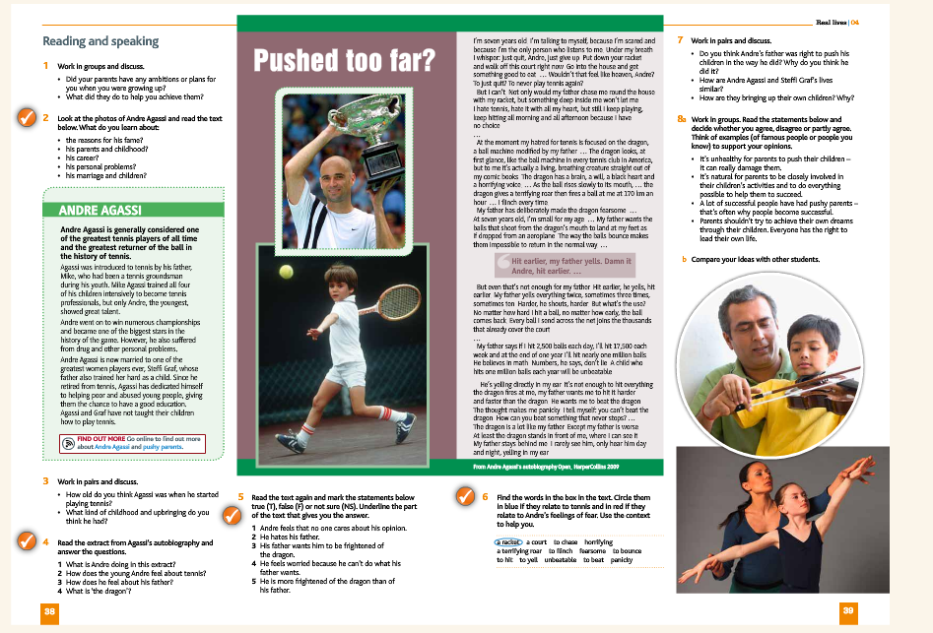
Cutting Edge Intermediate, Unit 4, pages 38-39

Questions:
Name 3 occupations you recognise from the pictures:
- ______________________________________
- ______________________________________
- ______________________________________
When you read the title of the article, would you say that the article is going to be about a positive or negative experience? Why

_________________________________________________________________________

___________________________________________________________________________

If you read the title of this article, and look at the pictures, can you predict the main idea of this article?

_________________________________________________________________________________________________________________________________________________________________________________________________________________________________
Can you guess where the pressure was coming from?
__________________________________________________________________________

Write 3 adjectives to describe how those people felt when they were young and growing up.

- _______________________________________________
- _______________________________________________
- _______________________________________________

